|  |  |
| --- | --- |
| Name | Zahoor Ahmed (21SW008) |
| Name | **Muhammad Shayan (21SW067)** |
| Project Name | **JobSeek Freelancing App** |
| Subject | **MAD CEP** |
| Teacher Name | **Ma’am Mariam Jawaid** |
| Section | **One** |

**Project Report:**

**JobSeek Freelancing App**

**Real World Problem Identification**

In today's gig economy, freelancers often face challenges in finding suitable job opportunities and establishing effective communication with clients. Many platforms are fragmented, making it difficult for freelancers to showcase their skills, connect with potential clients, and manage job applications efficiently. Additionally, clients may struggle to find qualified freelancers for their projects, leading to delays and dissatisfaction in the hiring process.

**Proposed Solution**

The JobSeek Freelancing App addresses these challenges by providing a user-friendly platform that connects freelancers with clients seeking their services. The app allows users to:

**- Find Work**: Freelancers can browse a variety of projects tailored to their skills and interests, enhancing their chances of securing jobs.

**- Find Talent:** Clients can explore profiles of freelancers, assessing their qualifications and past work, enabling informed hiring decisions.

**- Streamlined Communication:** The integrated messaging feature allows seamless communication between freelancers and clients, facilitating the discussion of project requirements and expectations.

**- Attractive UI:** The app is designed with an appealing user interface, ensuring a pleasant user experience while navigating through different features.

**Data Storage**

The application utilizes Firebase as the backend for user authentication, specifically during the login and signup processes. Firebase provides a secure and efficient way to manage user data while ensuring a smooth experience. The app does rely on Firebase for data storage in other screens like i.e. Proposal Form Submittion Screen, focusing instead on local state management and in-memory storage for the app's features.

**Screens Overview**

The JobSeek Freelancing App includes the following screens:

**1. Splash Screen:** A brief introduction to the app that showcases the logo with name and short quote, creating an inviting first impression for users.

**2. Login & Signup Buttons:** The main entry point for users, featuring buttons for login and signup, alongside icons for alternative login methods such as LinkedIn and Google.

**3. Login Screen:** A user-friendly interface for existing users to log in, with Firebase authentication integration for secure login and an option to recover passwords.

**4. Signup Screen:** A registration interface for new users to create an account, capturing necessary details like Name, Email, University and Password.

**5. Home Screen:** The central hub of the app, displaying available features, recent activities, and personalized content based on user preferences.

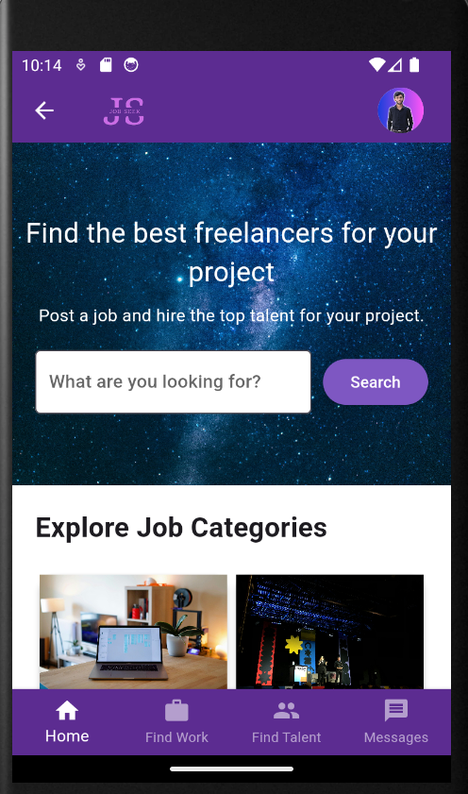

**6. Find Work:** A dedicated section where freelancers can browse available projects, filtered by categories, skills, or budgets, with an option to apply directly.

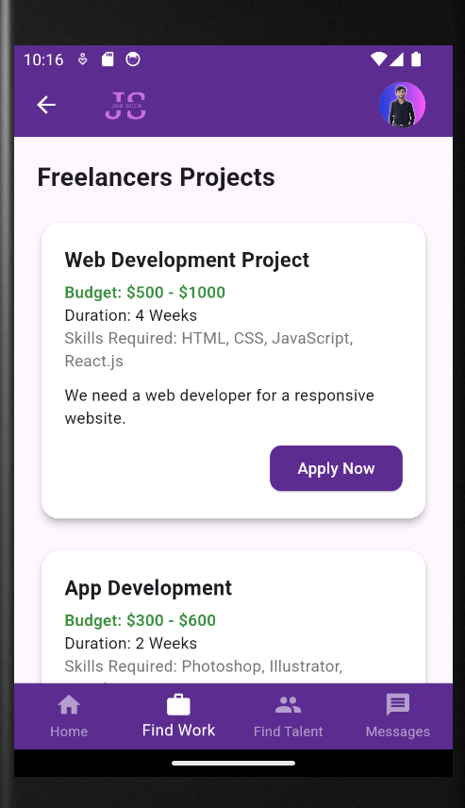

**7. Find Talent:** A feature that allows clients to search for freelancers by skills, experience, and ratings, facilitating easy talent discovery.

**8. Message Screen:** A section where users can view all their conversations, ensuring they stay updated on ongoing discussions.

**9. Conversations Screen:** A chat interface that allows freelancers and clients to communicate directly, fostering better collaboration.

**10. Profile of Freelancer:** A detailed profile page for freelancers, showcasing their skills, experience, and past projects, aiding clients in making hiring decisions.

**11. Submit Proposal Application Form:** A form for freelancers to submit proposals for jobs they are interested in, allowing them to outline their approach and bid for the project. After submitting, the proposal is securely stored in Firebase Firestore for easy access and management.

**Development Approach**

The development of the JobSeek Freelancing App follows an agile methodology, enabling iterative development and continuous improvement based on user feedback. The Flutter framework ensures cross-platform compatibility, allowing the app to run smoothly on both Android and iOS devices. Key components include:

**- User-Centric Design**: Focused on creating an intuitive interface that enhances user experience.

**- Firebase Authentication:** Implementing secure login and signup processes.

**- State Management:** Utilizing efficient state management solutions to handle user data and app state.

**Conclusion**

The JobSeek Freelancing App aims to streamline the freelancing process by connecting talent with opportunities while ensuring effective communication between freelancers and clients. By leveraging Firebase for authentication and Flutter for development, the app promises a reliable and attractive platform for users in the gig economy. The project addresses real-world problems faced by freelancers and clients, offering a comprehensive solution in a single application.